SCRAPBOOK PICTURES: CIENEGA FFA AND LITTLE RASCALS 4-H

Games played with State FFA Officers August 13,2012

Feeder Pig to raise for meat and for kids to learn about Swine

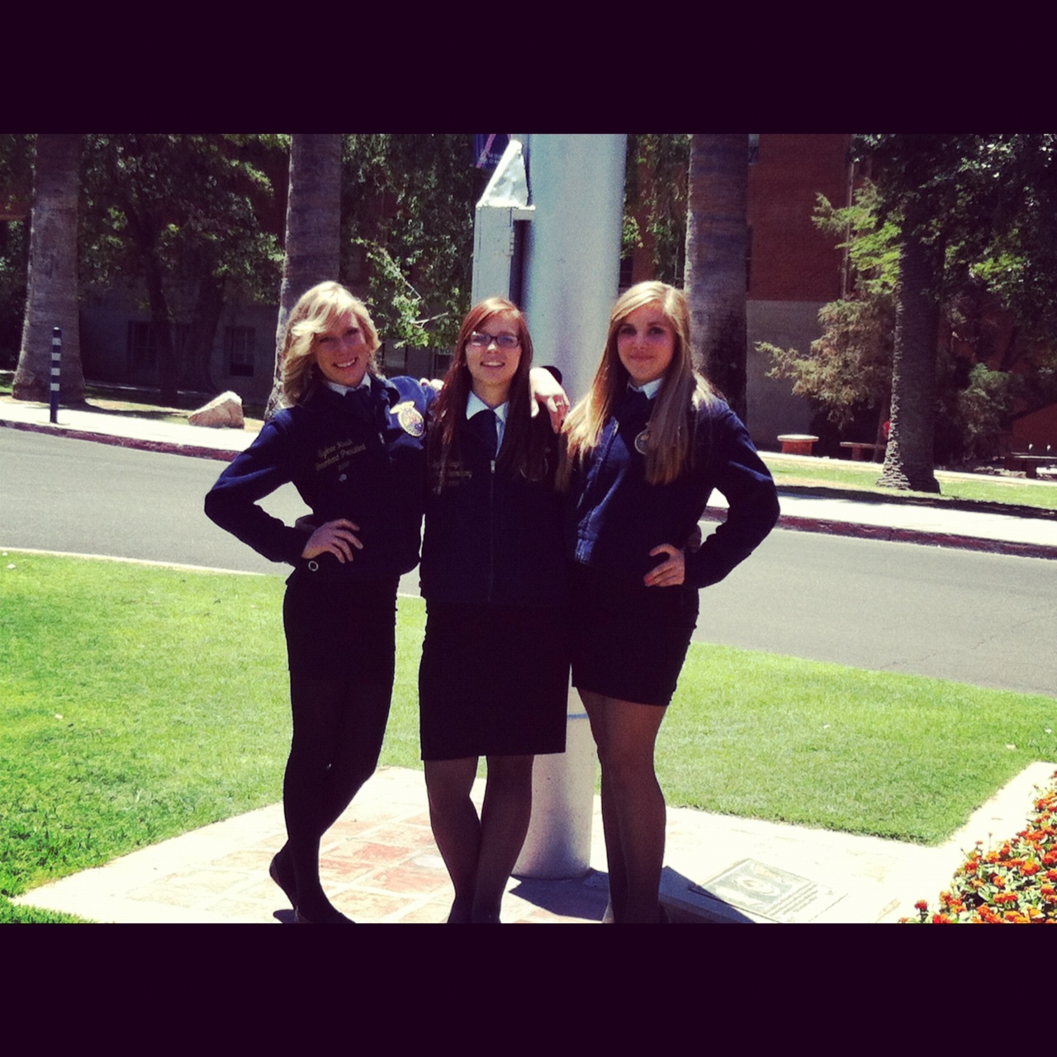

Chapter Officers Sydnee Rush, Baylee Teague and Bobi Pratt after State Leadership Conf. in June at the University of Arizona

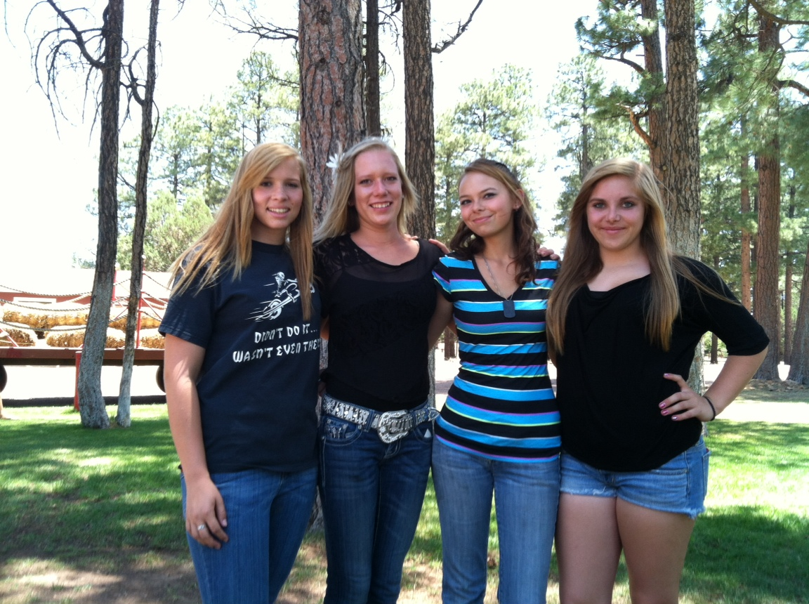

Baylee Teague, Sydnee Rush and Bobi Pratt with State FFA Camper at Heber in June

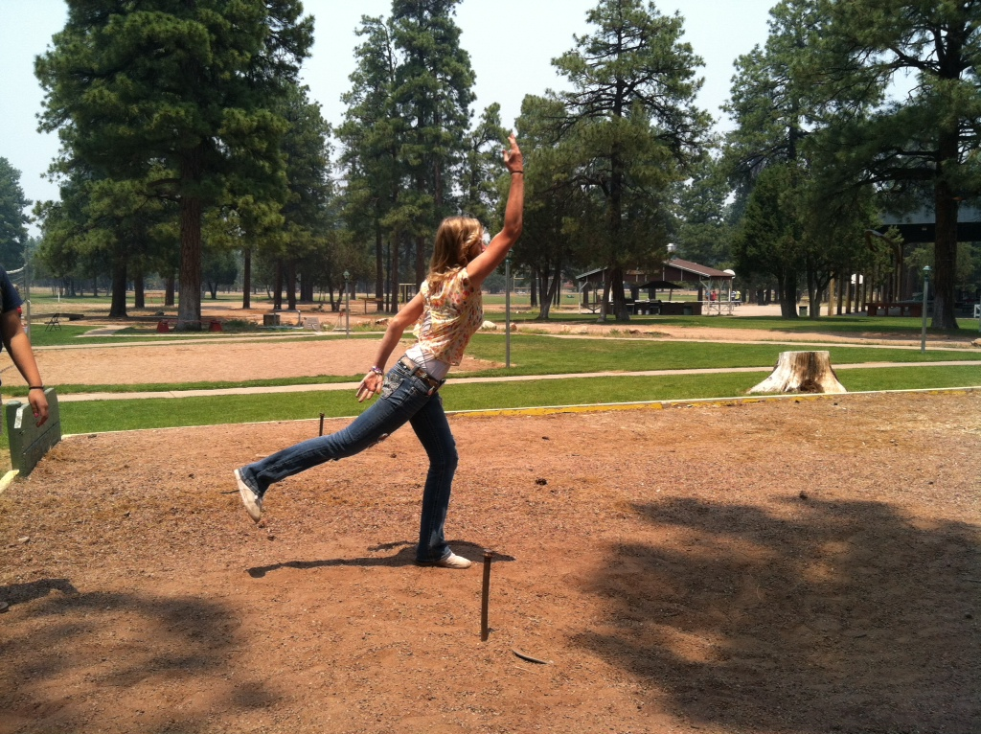

Having Fun at State FFA Camp in Heber, June 2012

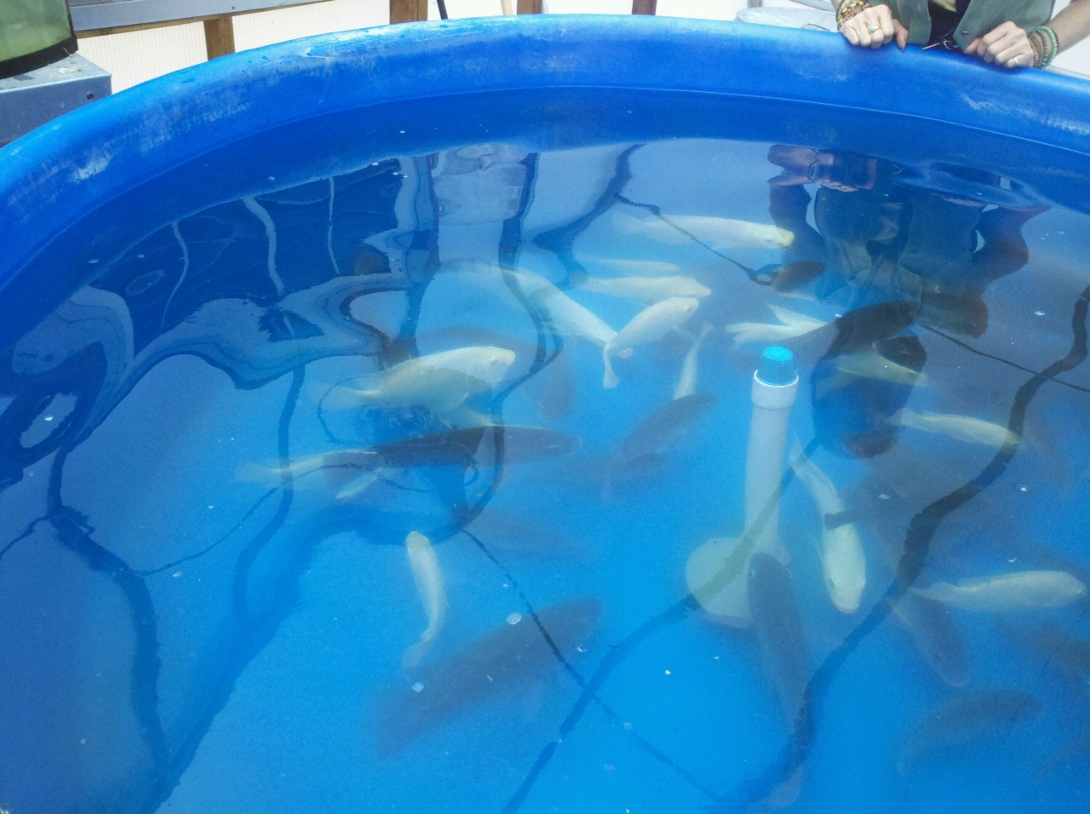

Aquaculture Tank in Greenhouse

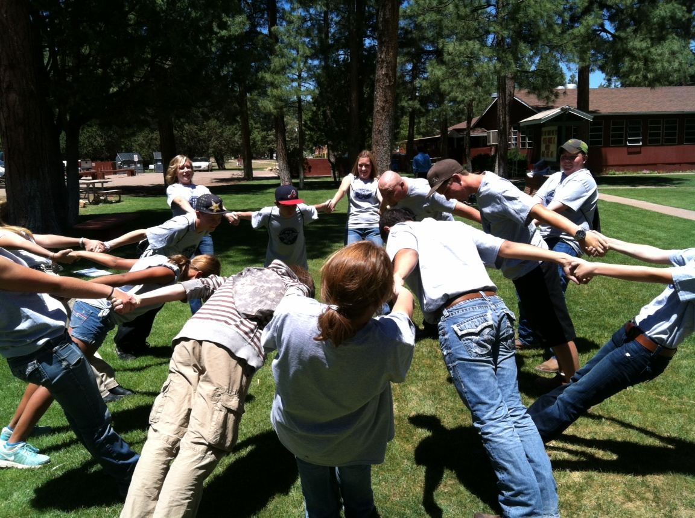

Having fun at State FFA Camp in Heber, June 2012

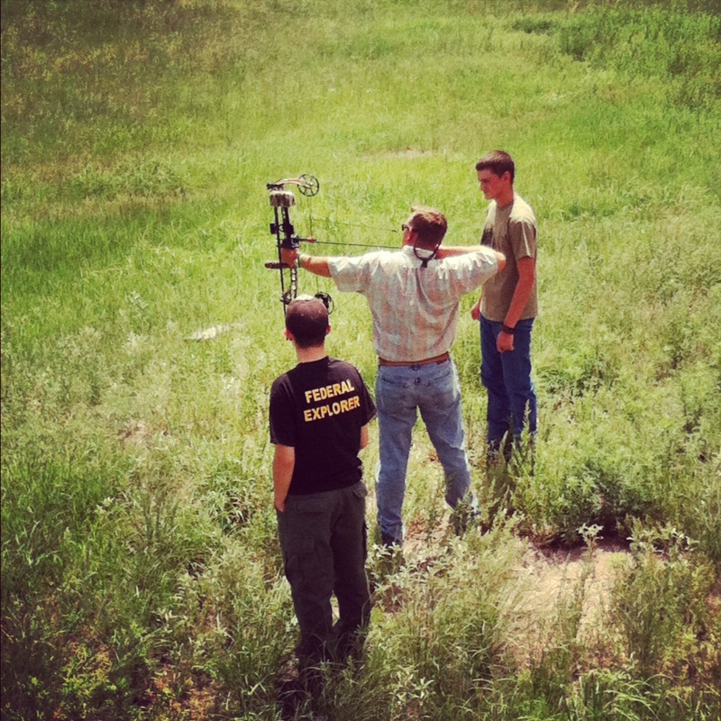

SAE visit at Shane Cubillas house in Sonoita, with Ty, Mr. Rush and Shane Cubillas

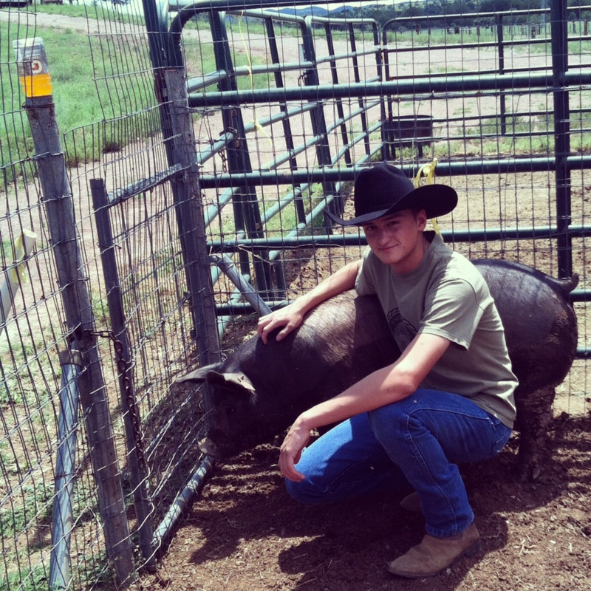

SAE visit in Sonoita with Shane Cubillas and his swine project

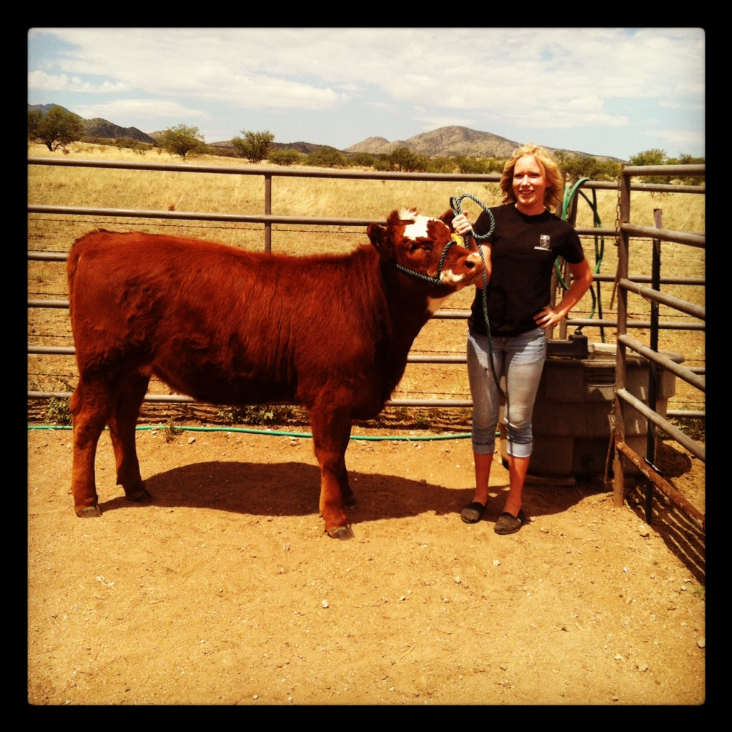

Sydnee Rush at Taylor Burelson’s place with Heifer
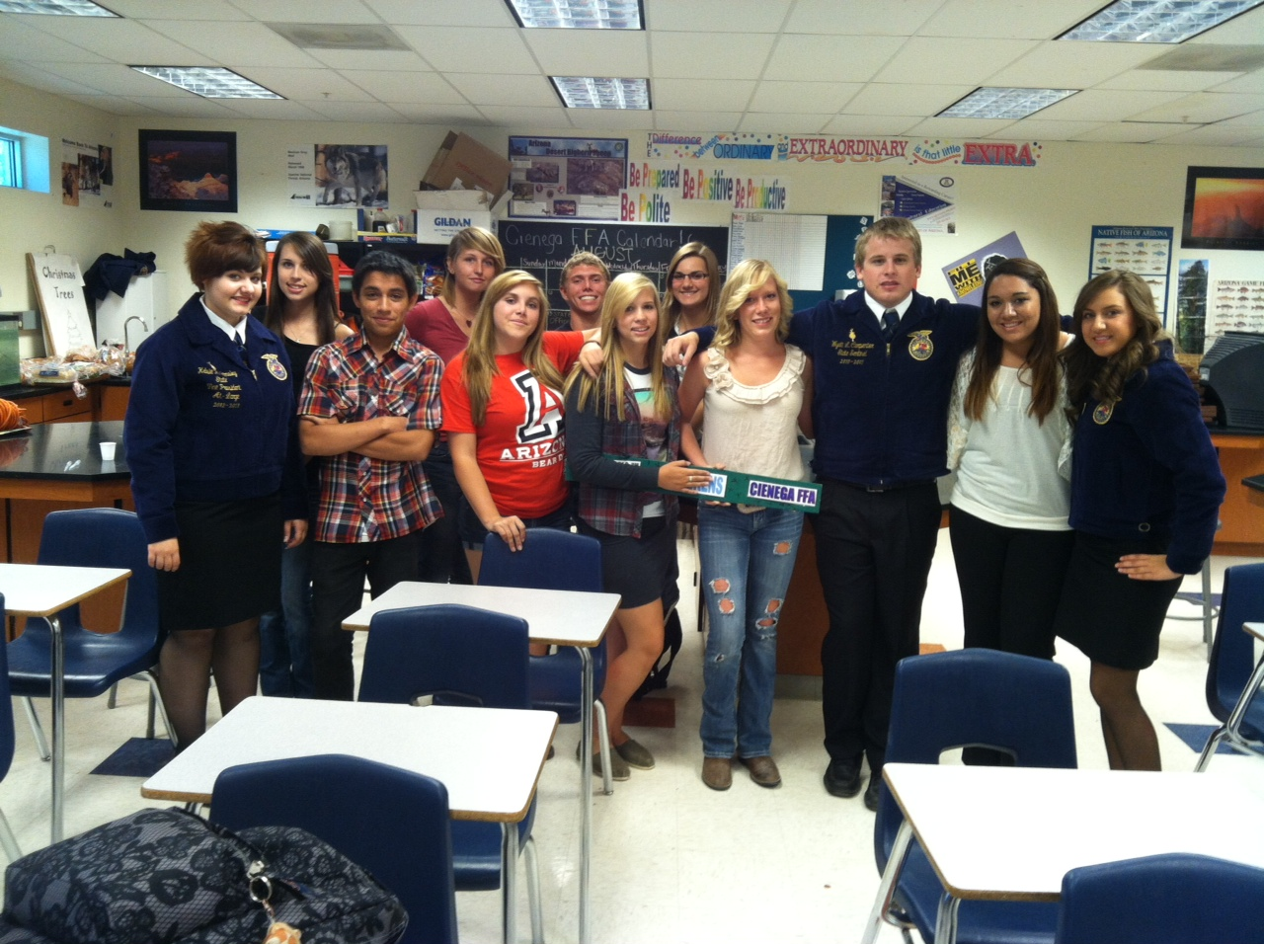

State Officers visit Cienega on August 13

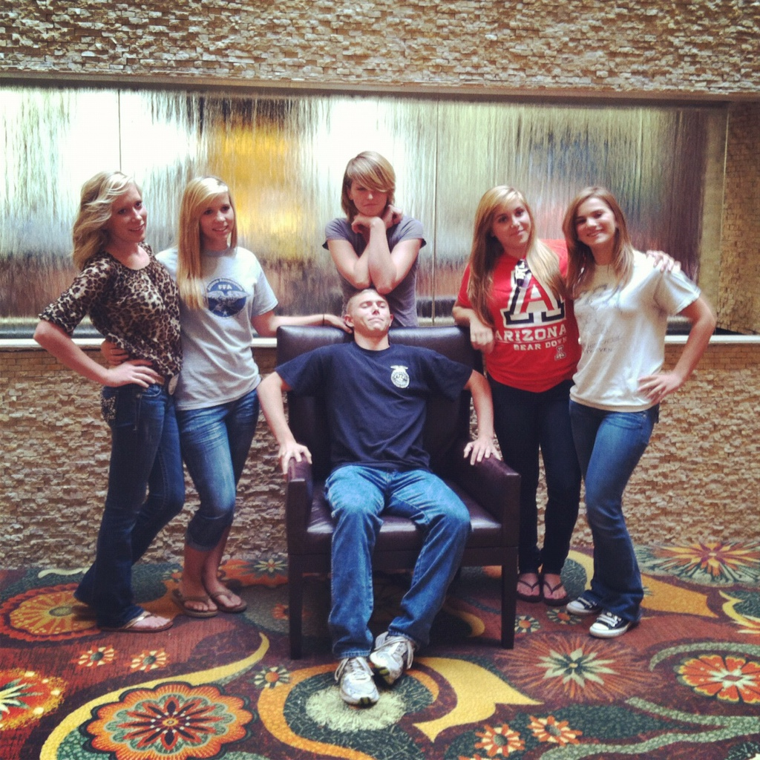

Chapter Officer Leadership Training in August at Hilton Hotel in Phoenix

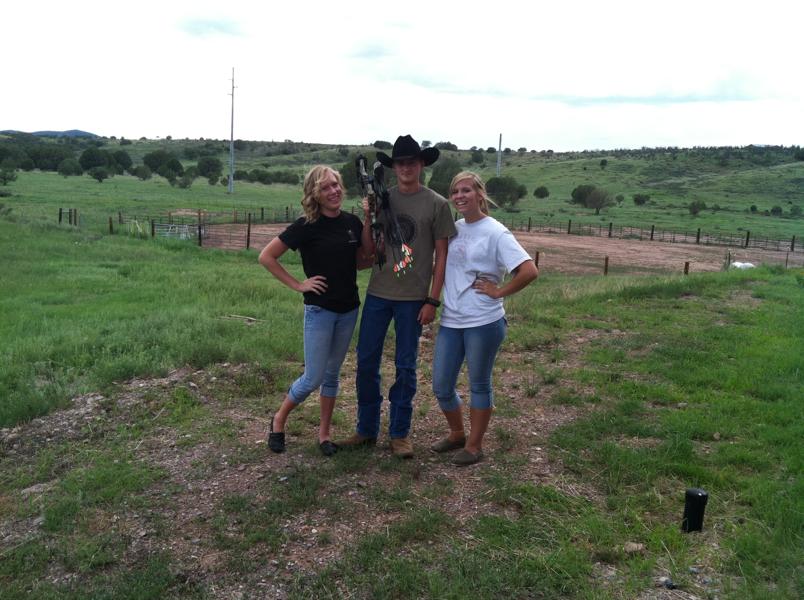

Sonoita SAE visit with Shane Cubillas, Sydnee Rush and Baylee Teague

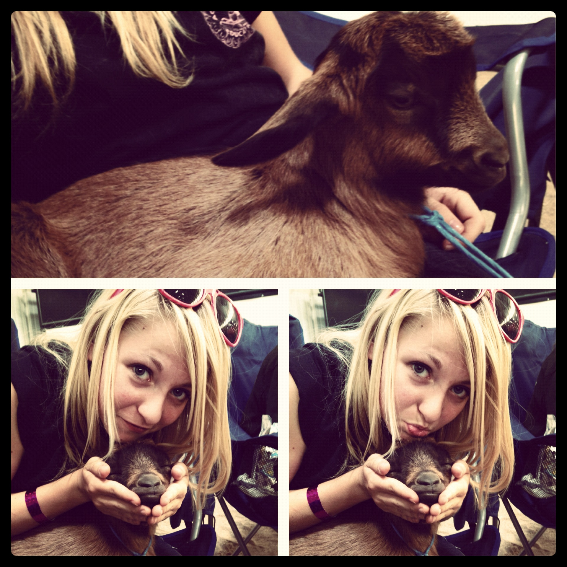

Pima County Fair 2012 with Sara Andreacola and goat

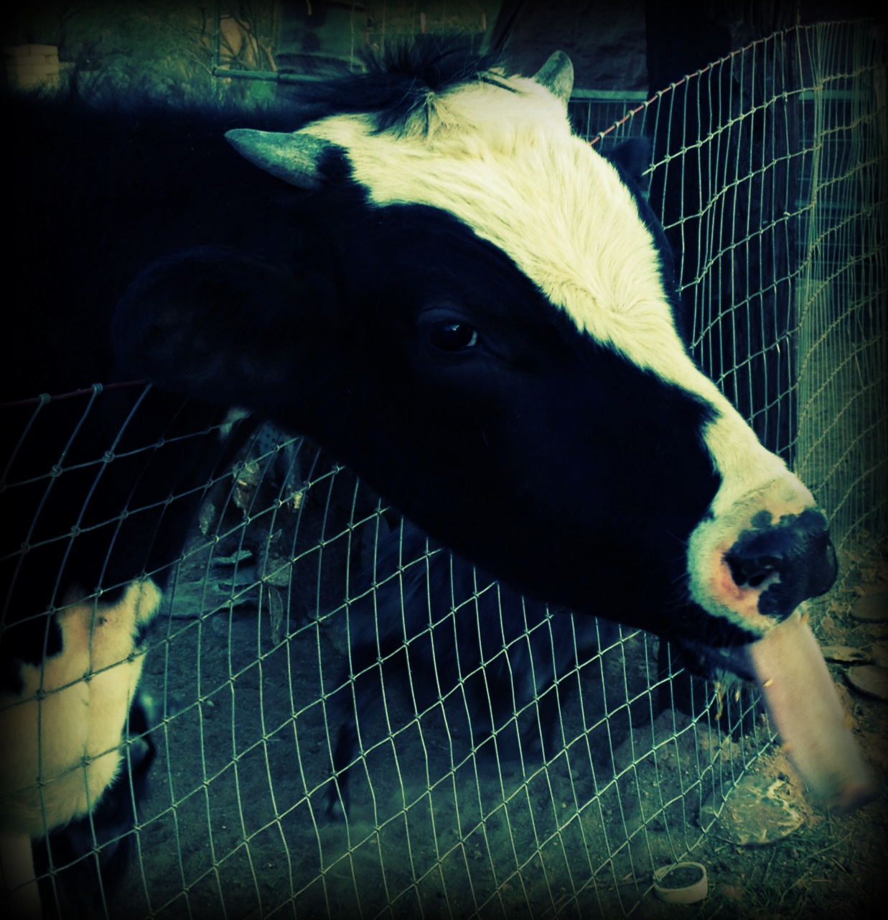

Norman the Holstein, used for Cow Pie Bingo Fundraiser and Meat

